产品说明书
Product description
产品简介Brief introduction of the product
不锈钢杆式液位计压力敏感核心采用了扩散硅芯体，内部的专用集成电路将传感器毫伏信号转换成标准电压、电流或频率信号，可以直接和计算机接口卡、控制仪表、智能仪表或PLC等方便相连。远距离传输可以采用电流输出方式。具有体积小、重量轻、不锈钢密封结构，可在腐蚀环境中工作。该产品安装方便简洁，具有极高的抗震和抗冲击性能，广泛应用于过程控制、航空、航天、汽车、医疗设备、HVAC等领域。
The pressure sensitive core of the Stainless Pole-type indicator with liquid level adopts diffusing silicon. Inside, the special integrated circuits transfers sensor millivolt signal into standard electric voltage, current or frequency signal, which enables to directly and conveniently connect with computer interface card, control panel, smart instrument or PLC, etc. The remote transportation can apply the transporting method in electronic current. It features with small volume, light weight and stainless hermetically-sealed construction, even working in corrosive environment. The installation of this product is convenient and easy, which possesses extremely high quake and shock resistance. As a result, it can be extensively applied in the fields including process control, aviation, aerospace, vehicles, medical facility and HVAC, etc.

技术参数：Technical parameters
电压：24VDC Voltage: 24VDC
输出：两线制4~20mA Output: two-wire system 4~20mA
量程：见产品标签 Range: check the product label
过程连接:G2 Procedure Connection: G2
本体材质：304 Material : 304
防护等级：IP65 IP Grade: IP65

接线示意图：Connecting Sketch Map
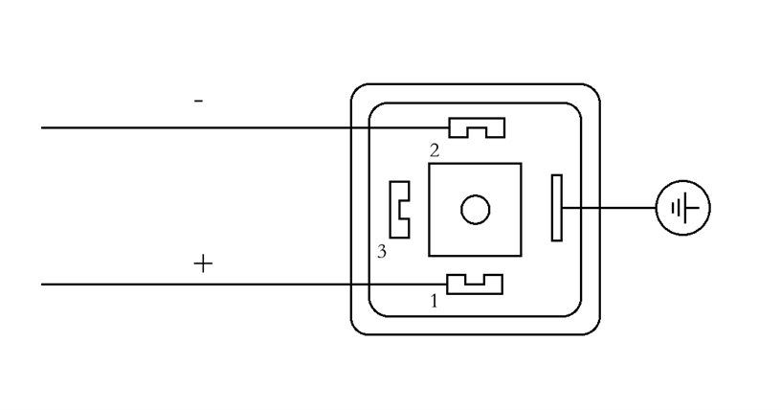
注：为了使变送器更加稳定工作，请务必按照规范接地。
Notice: To make the transmitter work more stably, please stay ground connecting according to the standards imperatively.

